**Project Name: Creating an Arithmetic Calculator**

**Developer Name: Kapil Davey**

**Project Description:**

1. The two numbers as well as the operator is acquired from the user.
2. A switch case is used to perform the specified operation on the two numbers. If the operator entered is incorrect, an error message is displayed.
3. Finally, the Arithmetic operation on two numbers is successfully done.

**Algorithm:-**

**Step 1**-Start

**Step2**-Enter Choice

Read choice i.e. (+, -, *, / , %)

**Step3**-Enter First number

Read number1

**Step4**-Enter second number

Read number2

**Step5**- (Perform addition)

If choice is equal to plus, then add number1 & number2 print the result

**Step6**- (Perform subtraction)

If choice is equal to subtraction, then subtract number1 & number2 print the result

**Step7**- (Perform Multiplication)

If choice is equal to multiply, then multiply number1 & number2 print the result

**Step8**- (Perform division)

If choice is equal to division, then divide number1 & number2 print the result

**Step9-**Stop

**Flow of project:**

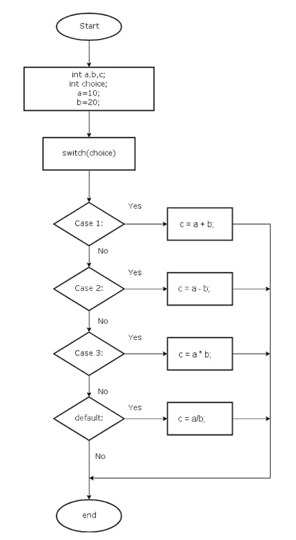

**Conclusion:**

The simple calculator is designed to perform the arithmetic operations by using the control statements.

**GitHub Reciprocity Link**:- https://github.com/kapildavey/Phase1.git